Selection of EPS

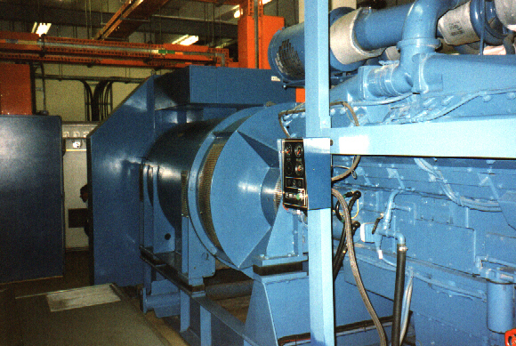
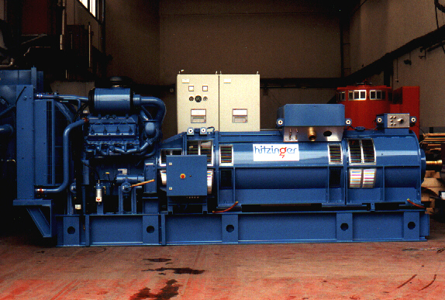
with
interruption
without
interruption
Selection of

Emergency Power Supply Systems

Hitzinger UPS
Type NBDD 1000 kVA
Hitzinger Short break
Type CSBG 450 kVA

Emergency Power Supply
with interruption

generating
set system
rotary short
break system
Combined short break /
generating set system

no energy storage
flywheel
energy storage
flywheel
energy storage

GEN SET
SBDS / SBDA
CSBG
A
15 s
300 ms
- genset mode : + 15 s
- short break mode : 300 ms
B
+ 10 %
- genset mode : + 10 %
- short break mode : + 10 %
C
+ 8 %
+5%/+5% (adjustable)
- genset mode : + 8 %
- short break mode : +5%(adj.)
+ 20 %

On special request other tolerances are available !

A : interruption time in case of mains failure
B : voltage transient for dynamic load step and switching from normal to emergency operation
C : frequency transient for dynamic load step and switching from normal to emergency operation

No Break Generating Sets
Emergency Power Supply
without interruption
A
B
C
NBDD
NBDK
0
0
+ 10 %
+ 10 %
+ 5 %
+ 1 %
A: interruption time in case of mains failure
B: voltage transient for dynamic load step and switching from normal to emergency operation
C: frequency transient for dynamic load step and switching from normal to emergency operation
dynamic UPS System
dynamic UPS System
kinetic
energy module
flywheel
energy storage
On special request other tolerances are available !

