KIN – Kinetic Module

The energystorage modulke KIN is the heart of
the

NBDK-Dynamic UPS-System

In case of mains failure the energy which is stored in the HITZINGER Kinetic Module supports the consumerbetween the loss of the utility supply and the load carrying ability of the the diesel engine.
Accurate frequency is ensured also during diesel engine operation

frequency transient at 100 % loadchange = max. +/-1 %
voltage transient at 100 % loadchange = max.+/-10 %

The brushless Hitzinger KIN – Module offers you:
high reliability, less maintenance and a high MTBF value

NBDK UPS- System KIN – description of function

Schematic view
2600 rpm

Diesel engine
Synchronous alternator

KINETIC-Module
1500 rpm

Flexible coupling
Elektromagnetic coupling
Outer rotor
Inner rotor

Simplified description:

The kinetic energy storage module KIN consists of two rotating parts→ the inner – and the outer rotor.
The outer rotor which is equipped with a squirrel cage rotates with 2600 rpm and runs freely on the shaft of the inner rotor.
The inner rotor equipped with an DC winding rotates with synchronous speed ( 1500rpm) coupled via flexible coupling to the synchronous alternator.
In case of mains failure the magnetic field of the inner rotor brakes the outer rotor and keeps the
speed of the synchronous alternator constantly via electronic conrol unit.

KIN - technical details
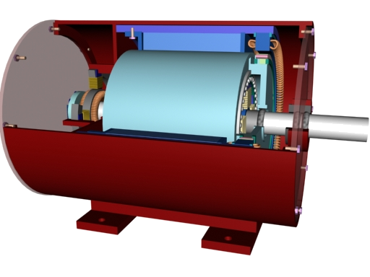
1
2
3
5
6
4
7

1 ... AC exciter machine
2.....Field winding of exiter machine
3.....Highspeed mass with laminat
4…..Inner rotor (DC Winding)
5…..rotor of the induction motor
6…. stator of the induction motor
7.....rectifiers

KIN – bearing temperature diagram

NBDK System Validation

K04730

KIN – oil leakage diagram

NBDK System
Validation

K04730

KIN – vibration trending diagram horizontal

KIN – vibration trending diagram vertical

