
Why use a UPS ?

There are at least 3 good reasons

third reason: to be independent from extern influences !

A reliable powersupply system means often a lot more than the quality provided by the local electricy board .

Certain Industrial processes react very sensitive on decreasing mains supply quality.
- Hospitals
- Airports
- Semi conductor production plants
- Chemical Industry/ plastics technology
- Electronic dataprocessing centers
- Telecommunication
- Computer controlled Industrial plants etc.
first of all: to save money !
mains failure of as a little as a millisecond will cause serious consquences and expensive production outage and subsequent mistake costs in a wide range of industrial, electronical, airports, computer centers and healthcare applications.
second reason: to prevent standstill of production !
Increasing degree of automation in modern production processes demands more than ever an absolute reliable and uninterrupted mains supply to prevent standstill and production losses .

„ What kind of UPS -System?“


UPS- System is the solution !



A Dynamic Uninterrupted Power supply- system from
is the solution for quality problems in mains supply of your organisation.

A - UPS System is taylormade regarding to your very
special situation and enables a return of investment during a very short time.
- Ratings: up to 2000kva
- Voltage up to 11 kv
- MTBF value: 20 years
- Low maintenance costs
- High alternator efficiency

We are sure to find the best state of the art solution at an affordable price
also for your application, with our No-Break Systems NBDD & NBDK .

The - UPS Systems enable you to reduce
production outages and prevent financial losses.

- Power factor improvement
- High quality of components
- High overload capability
- Optimum mains failure supervision
- In house developed PLC control system

NBDK UPS- System Technical Details
Static : + 1 %
Dynamic: a) at nominal load change, cos-phi = 0,8,: +10 %
recovery time 0,3 sec
b) during short circuit on incoming feeder + 10 %. The voltage tolerance
after switching off the short circuit is less than10 % recovery time 0,3 sec.
c) When switching off the incoming supply at nominal voltage + 10 %
and a recovery time of 0,3 sec.
Power: 100 – 2000 kVA
Voltage: up to 11 kV
Frequency: 50/60 Hz
Guaranteed Tolerances

Voltage

Frequency
Other tolerances / specifications are available on demand

a) during mains operation = mains frequency
b) changing from mains to diesel engine operation and an active load of 100 % + 1 %

c) statical - during diesel engine operation + 0,5 %.

NBDK Function
During stand-by operation consumers and the synchronous machine are both supplied via the choke from the mains. Consumer frequency is equal to the mains frequency. Synchronous machine maintains consumer voltage constant, irrespective of the mains voltage fluctuations and supplies most of the reactive power of the consumers.

The power factor on mains input is approx. 1.
Unsymmetric consumer current is shared from choke and synchronous machine symmetrically on all three phases on the mains input.
Consumers harmonics back to mains are largely filtered out.

In the event of mains failure, mains circuit breaker opens and consumers are supplied temporarely from the KIN (kinetic energy storage module). The electromagnetic clutch is energized diesel engine accellerates via highspeed-start to nominal speed.
The diesel engine becomes now the driving energy source and charges the KIN-Module again to be prepared for the next mains failure event.

On mains restoration, the consumers are back synchronized after a certain time delay period. Clutch opens and diesel engine is shut off after adjusted cooling down period.
A frame mounted radiator and an external electrical driven fan is used for Hitzinger NBDK´s. It ensures to eliminate radiated waste heat during stand-by operation as well as to cool the engine during mains failure periods when the diesel engine is in operation.

To shut down the NBDK system, the diesel engine is started and consumers are supplied via the by-pass circuit breaker which is synchonized to mains. Both CB´s (mains and alternator) are switched off and the machinery decelerates and shuts down.
Putting into operation is performed vice versa.

NBDK – Schematic diagram
Mains supply

14
15
16
17
12
11
7
8
10
9
1
3
6
4
18
Consumer voltage

18.clean power
By-Pass operation
Stand By-operation
Dieseloperation
Frequency drop = 1 %

13

14 Harmonic distortion
15 Voltage ipulse
16 Voltage drop
17 Outage

9 Costumer circuit breaker
10 Alternator circuit breaker
11 By-Pass- circuit breakerr
12 Mains input
13 Consumer Output

1 Diesel engine
3 Electromagnetic clutch
6 Synchronous machine
4 Kinetic module
7 Choke
8 Mains-circuit breaker

NBDK – Combi Technical details
Power: 100 – 2000 kVA
Voltage: up to 11 kV
Frequency: 50/60 Hz
Guaranteed Tolerances:

Voltage

Static : + 1%

Dynamic: a) at nominal load change, cos-phi = 0,8,: +10 %
recovery time 0,3 sec
b) during short circuit on incoming feeder + 10 %. The voltage tolerance
after switching off the short circuit is less than10 % recovery time 0,3 sec.
c) When switching off the incoming supply at nominal voltage + 10 %
and a recovery time of 0,3 sec.

Frequency

c) statical - during diesel engine operation + 0,5 %.
b) changing from mains to diesel engine operation and an active load of 100 % + 1 %
Other tolerances / specifications available on demand

a) during mains operation = mains frequency

NBDK - Combi function
HITZINGER has developed the NBDK Combi system to maintain critical loads and non-critical loads within one system.
This system provides the consumer the quality and continuity of electrical power which is required for UPS load and Emergency Power Supply as well

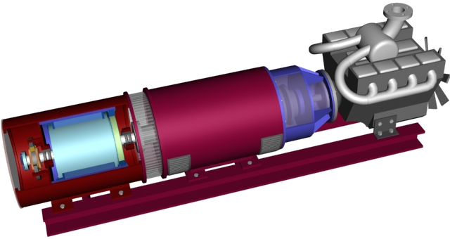
6
4
2
1

1 diesel engine
2 electromagnetic clutch
4 synchronous motor /alternator
6 kinetic module

Description of operation
During mains operation ( stand by mode) consumers and synchronous machine are both supplied via the choke from the mains and the kinetic module is fully charged.
This construction acts as a stabilizing filter and provides clean regulated power to the critical load.
The emergency consumers ( non critical load) are directly supplied form the mains.
In case of mains failure, mains circuit breaker opens and consumers are supplied without any interruption temporary from the kinetic module.
The diesel is started , the electromagnetic clutch is energized bevore engine reaches its nominal speed.
The diesel engine and the unit supply continousely the critical loads ( Frequency drop <= 1%).
A few seconds later when the diesel has reached nominal speed and the kinetic Module is charged again, the non-critical loads are connected to the system

NBDK - Combi Schematic diagram

7
1000
1555
1121
8
9
16
1434
13
1
3
4
6

1 diesel engine
3 electromagnetic clutch
4 synchronous motor /alternator
6 kinetic module
7 choke
8 mains circuit breaker
9 consumer circuit breaker
10 alternator circuit breaker
11 by-pass circuit breaker
12 mains input
13 consumer outlet UPS
14 consumer outlet EPS
15 by-bass circuit breaker II
16 alternator circuit breaker II

